**Practical-1**

**Aim: Write a C program to find the factorial of given 2 numbers using recursion.**

**Program:**

#include<stdio.h>

fact(int a)

{

if(a==1)

{

return 1;

}

else

{

return a*fact(a-1);

}

}

factn(int b)

{

if(b==1)

{

return 1;

}

else

{

return b*fact(b-1);

}

}

main()

{

int i,j;

printf("=> Enter the value of a :- ");

scanf("%d",&i);

printf("=> Enter the value of b :- ");

scanf("%d",&j);

printf("\n=> factorial of %d :- %d",i,fact(i));

printf("\n=> factorial of %d :- %d",j,factn(j));

}

**Output:**

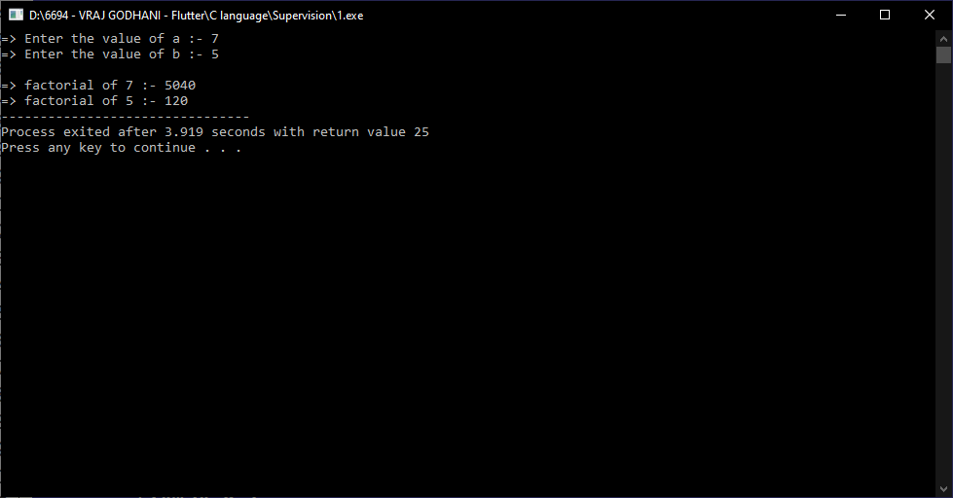

**Practical-2**

**Aim: Write a C program to find Sum of all Array Elements by passing array as an argument using User Define Function.**

**Program:**

#include<stdio.h>

int sum(int a[] ,int n)

{

int i,sum=0;

for(i=0;i<n;i++)

{

sum=sum+a[i];

}

return sum;

}

main()

{

int n;

printf("=> Enter size of array :- ");

scanf("%d",&n);

int i,a[n];

printf("=> Enter array elements :- \n");

for(i=0;i<n;i++)

{

printf("=> a[%d] :- ",i);

scanf("%d",&a[i]);

}

printf("\n=> Sum of all elements :- %d",sum(a ,n));

}

**Output:**

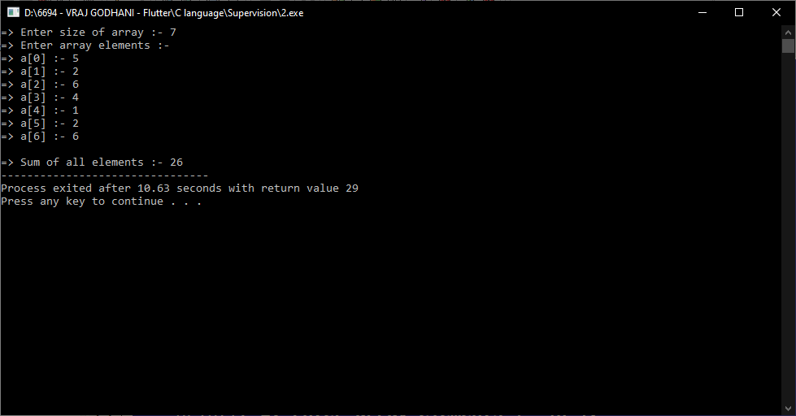

**Practical-3**

**Aim: Write a C program to find the length of the String by passing String as an Argument using the User Define Function.**

**Program:**

#include<stdio.h>

int length(char a[])

{

return strlen(a);

}

main()

{

char a[100];

printf("=> Enter any string :- ");

gets(a);

printf("\n=> Length of string :- %d",length(a));

}

**Output:**

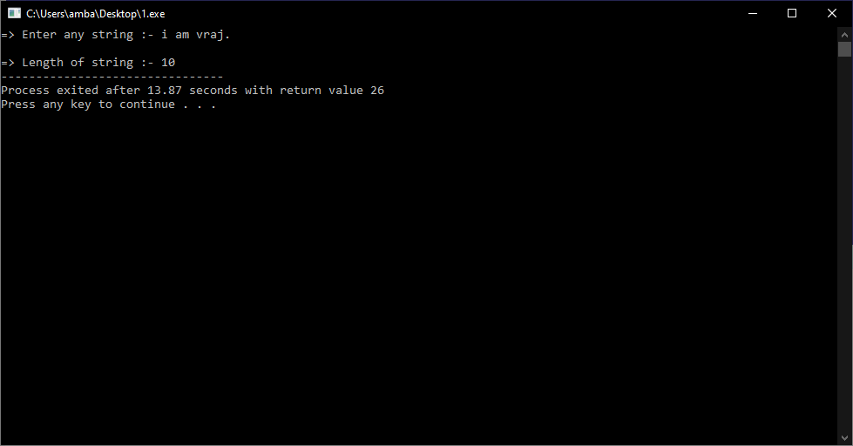

**Practical-4**

**Aim: Create a user defined function to find simple Interest, with Principal amount, no. of years, and rate as parameters.**

**Program:**

#include<stdio.h>

int intrest(int p, int r, int n)

{

int sum;

sum=(p*r*n)/100;

return sum;

}

void main()

{

int p,r,n;

printf("=> Enter Principal :- ");

scanf("%d",&p);

printf("=> Enter Rate :- ");

scanf("%d",&r);

printf("=> Enter Time in year :- ");

scanf("%d",&n);

printf("\n=> Simple intrest :- %d",intrest(p,r,n));

}

**Output:**

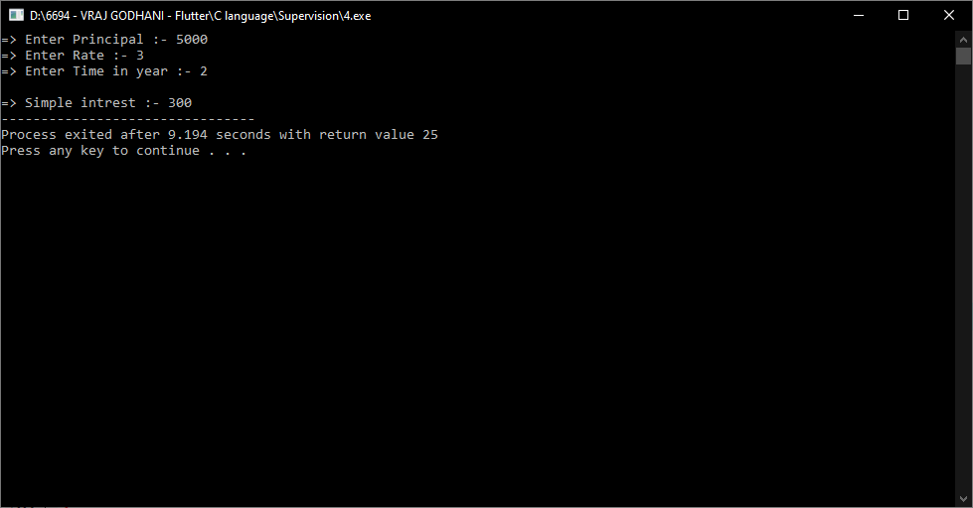

**Practical-5**

**Aim: Create user-defined nested functions that find the largest number among the given 3 numbers.**

**Program:**

#include<stdio.h>

void large(int a,int b,int c)

{

(a>b)

?(a>c)

? printf("\n=> a is greater.")

: printf("\n=> c is greater.")

:(b>c)

? printf("\n=> b is greater.")

: printf("\n=> c is greater.");

}

void main()

{

int a,b,c;

printf("=> Enter the value of a :- ");

scanf("%d",&a);

printf("=> Enter the value of b :- ");

scanf("%d",&b);

printf("=> Enter the value of c :- ");

scanf("%d",&c);

large(a,b,c);

}

**Output:**

